**Module 3 (RDBMS & Database Programming With JDBC)**

* 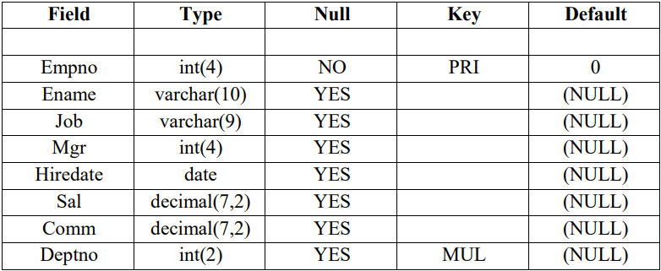**Employee Table Structure**
* **Employee Table Data**

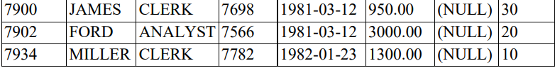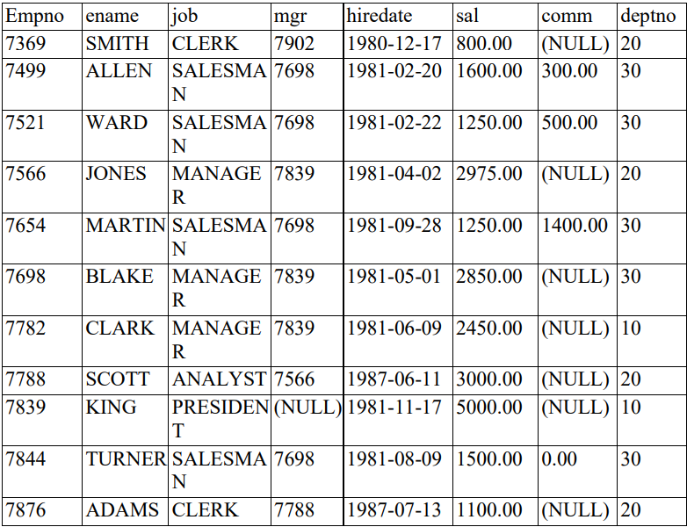

* **Department Table Structure**

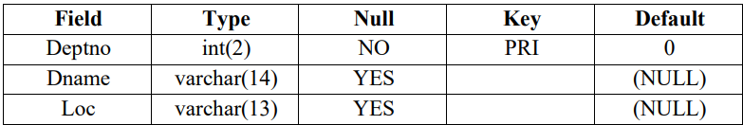

* 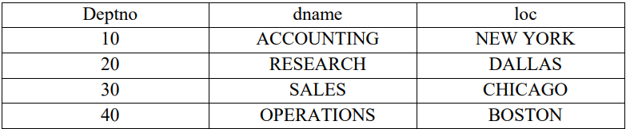**Department Table Data**
* **Emp_Log Table**

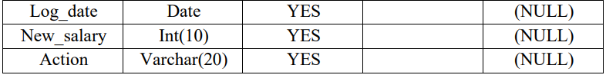

* **Student Table Structure**

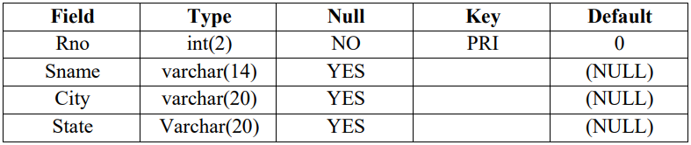

* **Queries**

1. **Select unique job from EMP table.**

**Query:** SELECT DISTINCT job FROM employee;

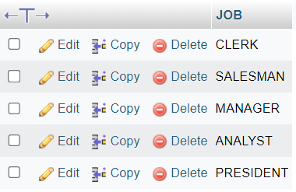**Output:**

1. **List the details of the emps in asc order of the Dptnos and desc of Jobs?**

**Query:** SELECT * FROM employee ORDER BY deptno ASC, job DESC;

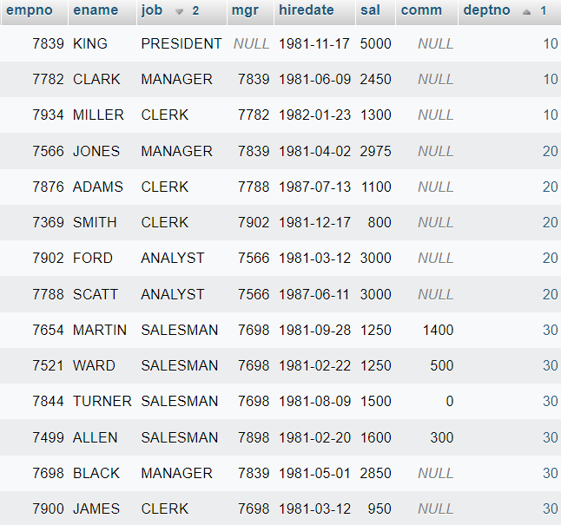**Output:**

1. **Display all the unique job groups in the descending order?**

**Query:**  SELECT DISTINCT job FROM employee ORDER BY job DESC;

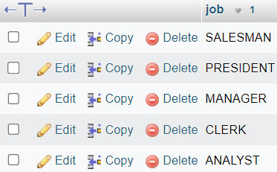**Output:**

1. **List the emps who joined before 1981.**

**Query:** SELECT * FROM employee WHERE hiredate < (‘1981-01-01’);

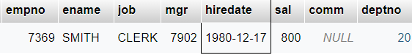**Output:**

1. **List the Empno, Ename, Sal, Daily sal of all emps in the asc order of Annsal.**

**Query:** SELECT empno, ename, sal Monthly_Salary, sal/30 Daily_Salary, sal*12 Anual_Salary

FROM employee ORDER BY Anual_Salary ASC;

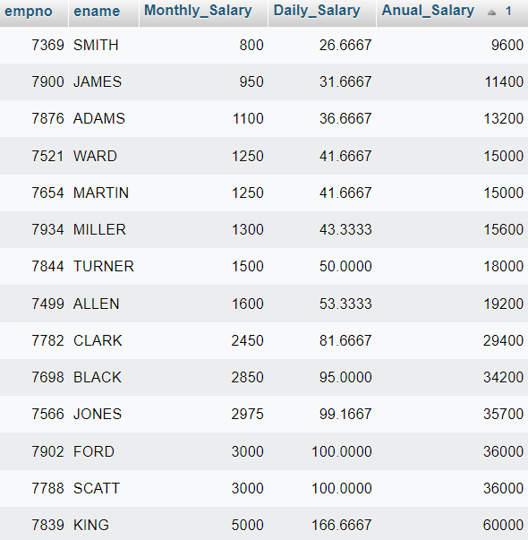**Output:**

1. **List the Empno, Ename, Sal, Exp of all emps working for Mgr 7839.**

**Query:** SELECT empno, ename, sal FROM employee where mgr=7839;

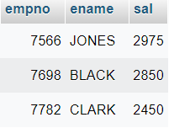**Output:**

1. **Display all the details of the emps who’s Comm. Is more than their Sal?**

**Query:** SELECT * FROM `employee` WHERE comm > sal;

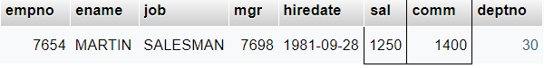**Output:**

1. **List the emps who are either ‘CLERK’ or ‘ANALYST’ in the Desc order.**

**Query:** SELECT * FROM `employee` where job='CLERK' OR job='ANALYST' ORDER BY job DESC;

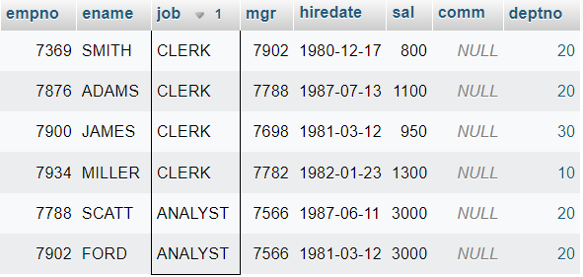**Output:**

1. **List the emps Who Annual sal ranging from 22000 and 45000.**

**Query:** SELECT *,sal*12 FROM `employee` WHERE sal*12 BETWEEN 22000 AND 45000;

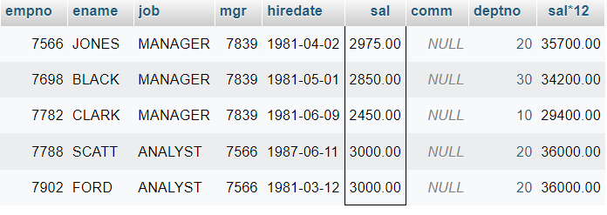**Output:**

1. **List the Enames those are starting with ‘S’ and with five characters.**

**Query:** SELECT ename FROM employee where ename like 'S%' AND length(ename) = 5;

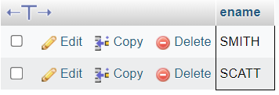**Output:**

1. **List the emps whose Empno not starting with digit78.**

**Query:** SELECT * FROM employee where empno NOT LIKE '78%';

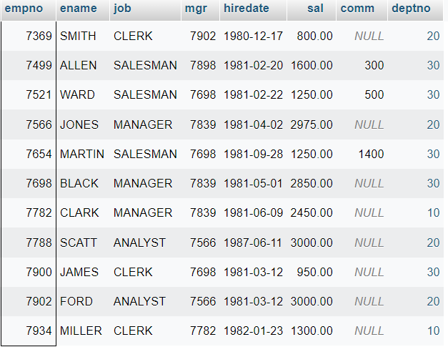**Output:**

1. **List all the Clerks of Deptno 20.**

**Query:** SELECT * FROM employee WHERE job='CLERK' AND deptno=20;

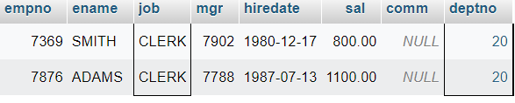**Output:**

1. **List the Emps who are senior to their own MGRS.**

**Query:**

**Output:**

1. **List the Emps of Deptno 20 who’s Jobs are same as Deptno10.**

**Query:** SELECT * FROM employee WHERE deptno = 20 AND job IN (SELECT DISTINCT job FROM employee WHERE deptno = 10);

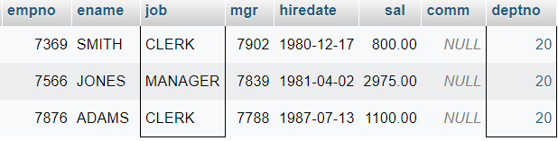**Output:**

1. **List the Emps who’s Sal is same as FORD or SMITH in desc order of Sal.**

**Query:** SELECT * FROM employee WHERE sal IN(SELECT sal FROM employee where ename IN('FORD','SMITH')) ORDER BY sal DESC;

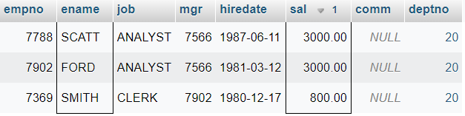**Output:**

1. **List the emps whose jobs same as SMITH or ALLEN.**

**Query:** SELECT * FROM employee WHERE job IN(SELECT job FROM employee where ename IN('ALLEN','SMITH'));

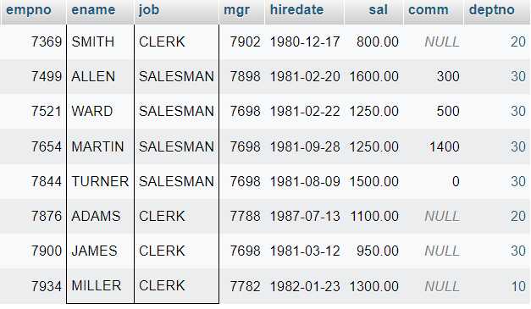**Output:**

1. **Any jobs of deptno 10 those that are not found in deptno 20.**

**Query:** SELECT * FROM employee WHERE deptno=10 AND job NOT IN(SELECT job FROM employee where deptno=20);

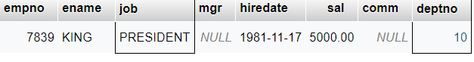**Output:**

1. **Find the highest sal of EMP table.**

**Query:** SELECT MAX(sal) FROM employee;

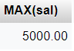**Output:**

1. **Find details of highest paid employee.**

**Query:** SELECT * FROM employee WHERE sal IN(SELECT MAX(sal) FROM employee);

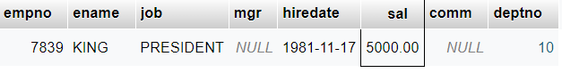**Output:**

1. **Find the total sal given to the MGR.**

**Query:** SELECT sum(sal) FROM employee where job='MANAGER';

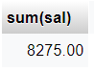**Output:**

1. **List the emps whose names contains ‘A’.**

**Query:** SELECT * FROM employee where ename LIKE '%A%';

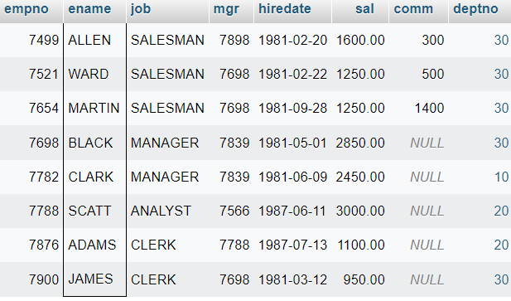**Output:**

1. **Find all the emps who earn the minimum Salary for each job wise in ascending order.**

**Query:** SELECT * FROM employee WHERE sal IN(SELECT MIN(sal) FROM employee GROUP BY job) ORDER BY sal ASC;

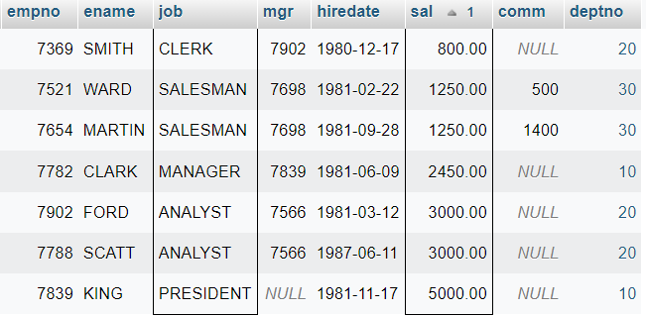**Output:**

1. **List the emps whose sal greater than Blake’s sal.**

**Query:** SELECT * FROM employee WHERE sal > (SELECT sal FROM employee WHERE ename='BLACK');

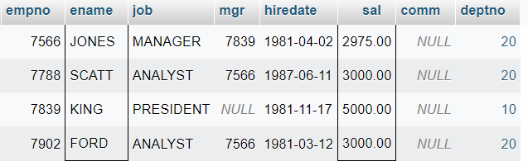**Output:**

1. **Create view v1 to select ename, job, dname, loc whose deptno are same.**

**Query:**

**Output:**

1. **Create a procedure with dno as input parameter to fetch ename and dname.**

**Query:**

**Output:**

1. **Add column Pin with bigint data type in table student.**

**Query:**

**Output:**